North Creek Water Quality Analysis Final Report
University of Washington Bothell

Written by Kent Parkinson
Fall 2013

Introduction
In the fall of 2012 a consultant group named GeoEngineers was collecting water samples from the North Creek watershed and investigating the water quality of the North Creek and the wetland depressions residing within the boundaries of the University of Washington’s Bothell campus. These samples evaluated the amount of E. Coli. Bacteria and other coliform bacteria’s within the waterway and throughout the wetlands. As recent as April of 2013 these coliform counts were exceeding 500,000 CFU’s per 100 mL at one of the micro depressions being tested.(GeoEngineers 3/2013) This was an indication that the coliform bacteria counts had spiked within University of Washington Bothell wetlands, hence bringing up the question of its source, which was unknown. Testing before this particular report also indicated high levels of bacteria in the same depression (NC-2c), but this was a significant increase Due to these findings a team of University students began a research project developed to monitor the water quality of the North Creek waterway that travels through the University of Washington Bothell campus. This waterway is the end result of a heavily urbanized watershed with head waters beginning in south Everett Washington and terminating just south of the University of Washington Bothell campus wetlands in the Sammamish River. This study started in April of 2013 and lasted through December of 2013 for the purposes of this report, however the research is ongoing so that a larger data base may be compiled for future researchers. Following is the initial findings of the research done thus far.
Water samples were collected and analyzed on a weekly basis with the intention of monitoring the water quality over an extended period of time as it travels through the wetland, and to determine if possible the source(s) of the high levels of bacteria found in these wetlands. At the beginning of this study there were a couple of hypotheses as to the source, one being a leaking sewer line leaching into the ground water and North Creek its self, or another possibility being the large deposits of feces that have been continuously deposited in the wetlands from a flock crows that roost in the area on a nightly basis. It is important to note that this flock population varied during this portion of the study, but is believed to be of significant numbers. The population density of these birds seemed to decrease during the Spring and Summer months but a noticeable increase in the population became apparent during the course of Fall into early Winter.
The University of Washington wetland is the site of a young restoration effort only spanning approximately 16 years in successional development. There are many native trees and plants that may be attracting the wildlife that has been recorded in these studies including the crow population. It is an important part of this watershed adding to the connectivity of a wildlife corridor and helping to reduce environmental fragmentation in the region.

Discussion
This is a continuation of a three-phase project that began Spring quarter 2013, to set a baseline of data that can be used in the future for studies that may involve pathogens in the wetland waters of North Creek. We are gathering data to have a better understanding of fecal coliforms and, in particularly, E-coli issues that are plaguing the North Creek watershed and its wetlands. It is possible that the numbers of crows roosting in the trees in the wetland are causing an increased influx of fecal coliform bacteria or that there is a sewage leak problem from a King County Metro sewer line that intersects North Creek on the University’s campus or an intercept line of King County’s that resides upstream. It is the intention of this research to continue collecting data and gathering enough information to see if conclusions can be drawn from the results on whether or not the University’s wetlands are adding to the problem of elevated coliform bacteria levels. However this report is designed to be used as base line data in conjunction with the rest of the study’s documentation both past and future. Four sites were chosen to study this quarter, three of which remain the same from last quarter but have been identified in a different format.
Site 1 was reintroduced from Spring quarter as a benchmark for what is coming into the wetlands. Sites 2, 3 and 4 for Fall quarter remained in this study from Summer quarter for their relevance in accordance with the initial report presented at the beginning of this research project. That report indicated a spike in pathogens produced for the University of Washington. (Table 1). Is Fall quarters data collection which began October 1, 2013 and ended December 3, 2013 and was collected on a weekly basis. Site 1 is located north of the University of Washington Bothell wetlands across Interstate 405 in the North Creek Business Center. Site 2 is located ~30m north of the secondary channels mouth of the North Creek on the University’s campus. Site 3 is located ~10m south of the secondary channel outflow of North Creek just south of the boardwalk. Site 4 is the southernmost site on the University’s campus located next to State Highway 522. (Please refer to Map 1)

Methodology
In the Field
The first piece of equipment used to gather data at all sites was YSI 85 meter which detects oxygen levels (% saturation and milligrams per liter), temperature (˚C), and conductivity (micro Siemens). Other equipment used was an Oakton pH Tester 10 and a 2100P Turbidimeter. First thing that was done each week before collecting data was calibrating the YSI 85 meter and the Oakton pH meter in the lab before going into the field. At the beginning of the quarter, the 2100P Turbidimeter was calibrated before going out in the field the on October 1, 2013. To collect data using the YSI 85 meter, the probe was hung off a branch, lowered into the flowing water, and left while collecting other data which allowed it to stabilize. To get a pH reading the Oakton pH meter was submerged roughly 4 inches into the stream and was held there for 2 minutes, allowing the pH to stabilize. To collect turbidity readings, three glass vials and their lids were submerged to a depth of ~6 inches three times to rinse, then on the fourth time filled and capped. Before the readings were taken, each vial was wiped clean and dry using Kimwipes then slowly inverted 5 times before placing in the 2100P Turbidimeter. To gather samples, new disposable 20ml sterile containers were used to ensure there was no contamination. When the data was being gathered we started at the downstream Site (Site 4) and worked our way up to Site 2 so that we did not stir up sediments since we had to get in the stream channel to collect samples and the other data. Site 1, however, was collected with an identical set of equipment and handled in the same fashion by another research team member(s) because it was off campus and required transportation to get to the site. At each site, three replicates were taken as well as one control containing deionized (DI) water. The University of Washington Bothell supplied the DI water. All containers were filled and rinsed three times, then on the fourth time the sample was collected and capped. For the North Creek samples, the vials were submerged ~6 inches to rinse as well as the final samples that were immediately returned to the lab for processing.

  - In the Lab
Once samples were brought back to the lab, they were immediately prepared for filtration by diluting them to 1%. This was done by using a 100ml graduated cylinder and adding 99ml of DI water then 1ml of sample was added by pipet to create 100ml of solution. The solution was poured into a 200ml beaker and swirled at least 25 times to ensure it was mixed. These diluted samples were then filtered through a Millipore 47mm membrane using a vacuum pump. The membranes were then placed into Millipore single use 47mm petri dishes which were pre-prepped with m-Coliblue broth culture medium. The petri dishes were then placed in an incubator that was preheated to 35°C and incubated for twenty four hours, then placed in a refrigerator. The samples were kept in the refrigerator for less than twenty four hours before counting was done. Using a Nikon SMZ1500 microscope, total coliform (red colonies) and E-coli (blue colonies) were counted. After counting was done, calculations to get total bacteria counts in 100ml were performed. The formula for the calculations is (total colonies counted / ml original solution)*100ml. Means of results are presented in Table 1 and totals for each date collected for each site in Appendix 1,2,3 and 4. All filtration equipment was sterilized in a 70% Ethyl alcohol solution after each site’s samples were filtered and allowed to air dry in a fume hood.

Results
Table 1.
Variables measured along North Creek at University of Washington Bothell campus wetlands during Fall quarter 2013. Means (n=10) are presented ± Standard Deviation. * indicates n=9, ** indicates n=8 and *** indicates n=7.

Table 1

VARIABLES |  | SITE 1 | SITE 2 | SITE 3 | SITE 4
O2 % |  | 88.17 ± 8.07* | 91.17 ± 8.00*** | 87.03 ± 10.10** | 95.16 ± 7.41*
O2mg/L |  | 10.52 ± 1.27* | 10.23 ± 1.66*** | 10.07 ± 1.15** | 11.17 ± 1.20*
PH |  | 7.36 ± .31*** | 7.29 ± .26*** | 7.34 ± .31** | 7.24 ± .28*
TEMP C |  | 8.77 ± 2.72* | 9.54 ± 2.46*** | 8.84 ± 2.90** | 8.57 ± 2.75*
CONDUCTIVITY. US |  | 125.44 ± 39.76* | 124.65 ± 20.62*** | 112.73 ± 34.70** | 146.5 ± 29.27*
TURBIDITY. ntu |  | 4.32 ± 2.00** | 3.82 ± 1.87*** | 4.10 ± 1.62** | 3.79 ± 1.66*
OTC |  | 3181.67 ± 2703.49* | 3390.71 ± 2429.32*** | 3516.88 ± 1968.25** | 3689.11 ± 2027.34*
E.COLI |  | 241.22 ± 149.72* | 395.57 ± 387.14*** | 708.75 ± 412.66** | 763.67 ± 456.37*
TFC |  | 3422.67 ± 2675.85* | 3786.29 ± 2624.19*** | 2830.97 ± 1842.63** | 4096.38 ± 3668.71*

In comparison to data collected during Spring and Summer 2013, it would appear that the E. coli. counts dropped off significantly, however, they are starting to climb as the Winter 2013 ensues. It would also appear that the other coliform bacteria counts went down and are begging to climb in the same pattern. It is important to point out, however, that there seems to be a trend developing this quarter (Fall 2013) that was not apparent the last two quarters. In fact, developments seem to have reversed when it comes to bacteria counts as the water travels through the wetlands. When looking at the data it seems to have a pattern of increased bacteria levels from source to termination, hence an indication that the wetlands may be maxed out and unable to handle the influx of bacteria coming into the wetlands from other sources outside its boundaries. Parallel studies are underway to determine what the bacteria levels are in the soils and depressions that exist within these wetlands, and results have been documented by this author for further interpretation in the future.
It is also evident that the bacteria counts are climbing before the waters reach the wetlands once the raw data was analyzed. Other variables to be considered start with water flow over the course of this quarter (Fall 2013) in comparison to previous quarters used in this study. There has been a steady increase of rainfall over the course of this quarter’s sampling (Fall 2013). Due to this variable, fluctuations in the bacteria counts occurred, but overall count have begun to climb. This being the case, it would also appear that the crow-roosting areas within the wetlands may also be a contributing factor now that the avian population seems to be returning to the area. Earlier quarters did not have the population duration (amount of time roosting) of crows visiting the wetlands like they are during the late fall and winter months. In all bacteria counts, it looks like there are increases from Site 1 in comparison to site 4. This was not the case during Summer 2013, in fact, it was the opposite looking at the average data tables. Figures 1-4 are descriptions of the sites we sampled, and following those are the appendices relating all raw data for this particular study during Fall quarter 2013.

Map 1
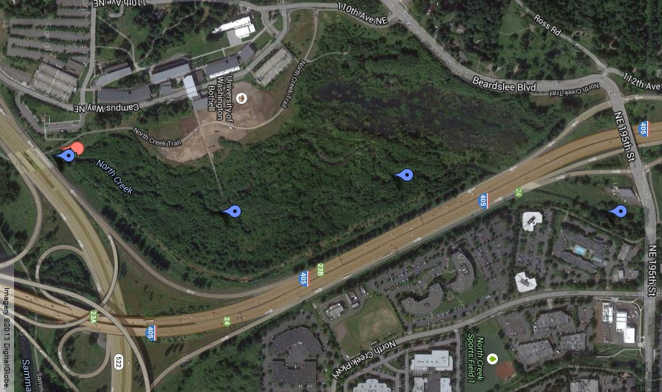
Map produced by Philip Van Valkenburg and Kent Parkinson
Site 1
Site2
Site 3
Site 4

Figure 1.
Water quality sample Site (1) is on the North Creek. It is north of the University of Washington Bothell campus wetlands. This site was reintroduced this quarter from last Spring quarter’s study to further track what is flowing onto the University of Washington’s Bothell campus wetlands. Last Spring 2013 it was listed as site 6. Its GPS coordinate is N47.76820/W122.18732.
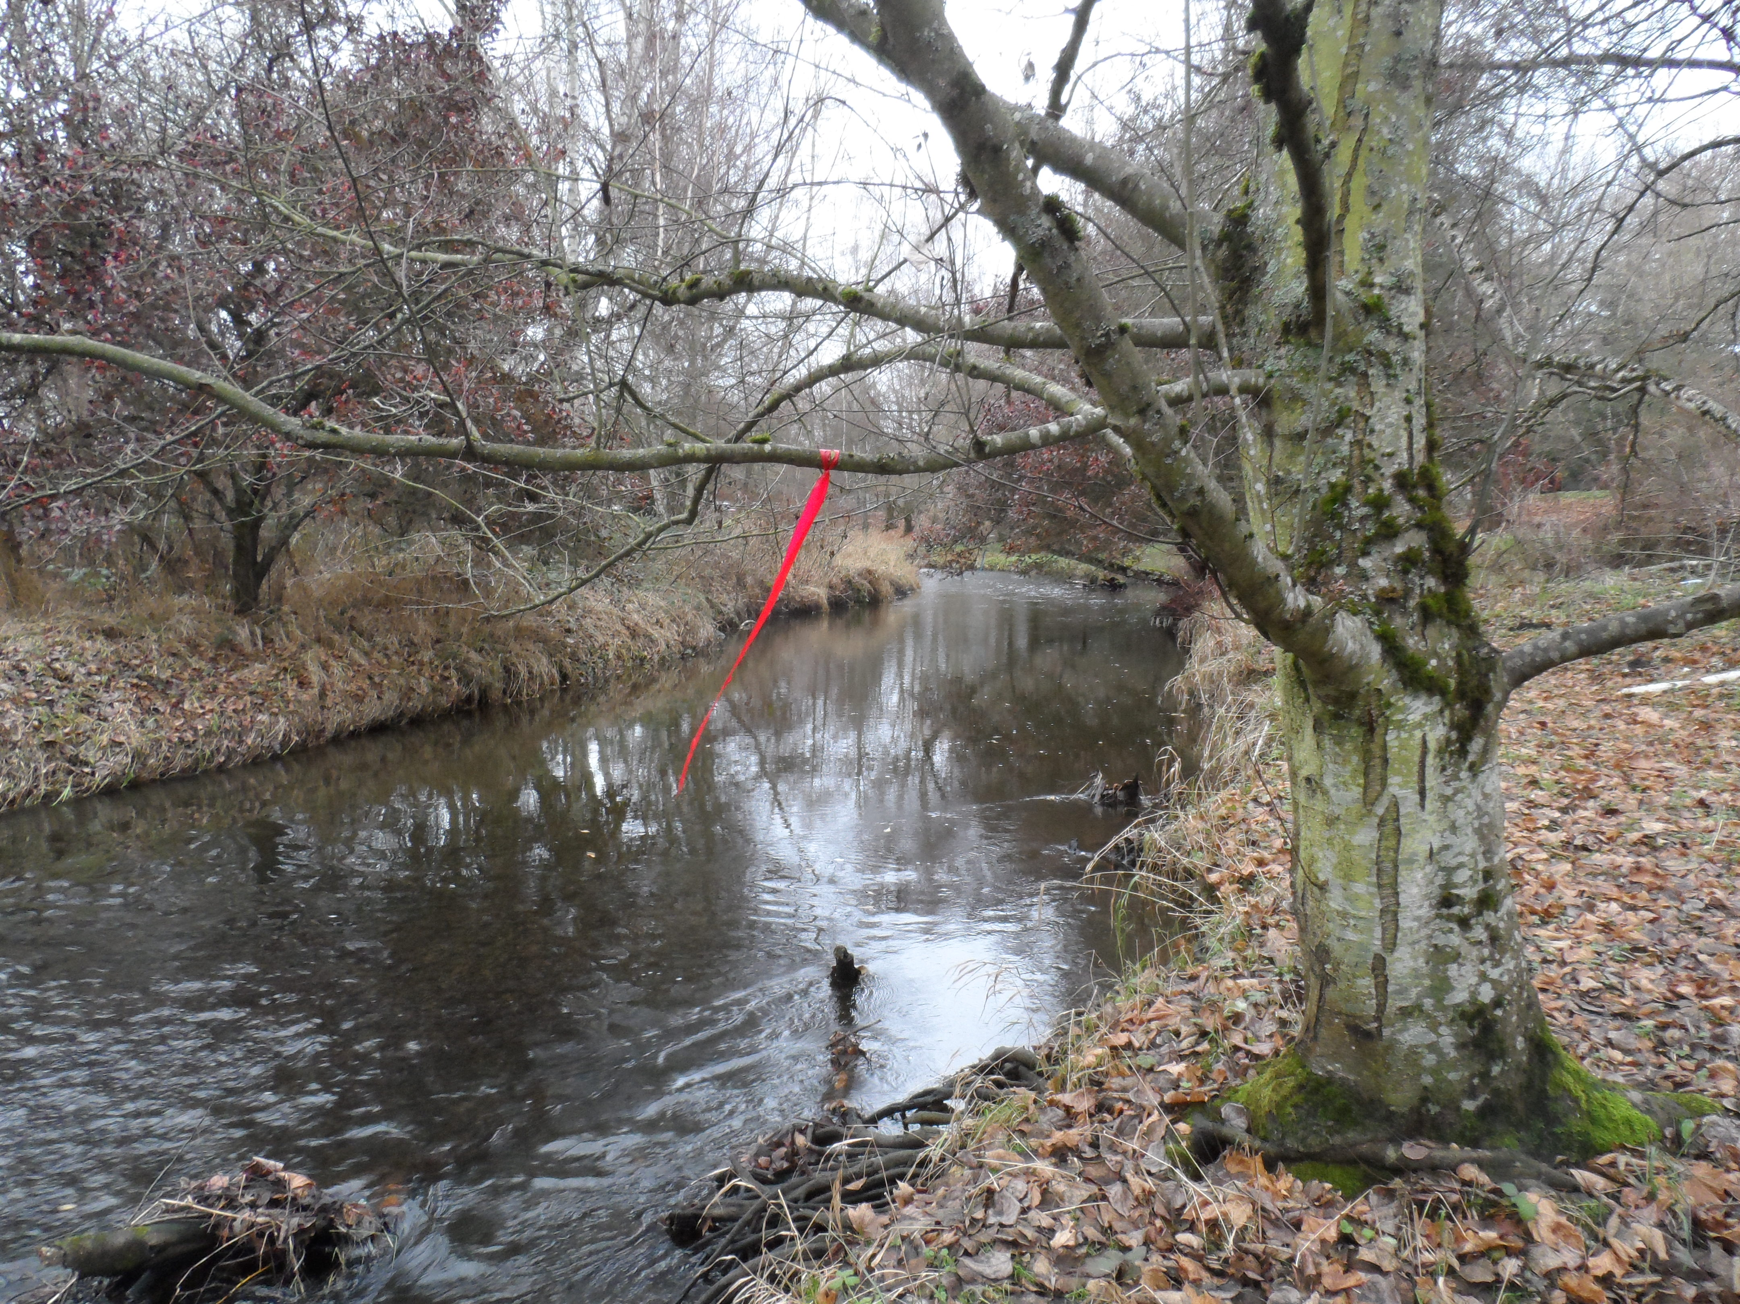
Photo by Kent Parkinson

Figure 2.
Water quality sample Site (2) is on the North Creek and a continued site from all three quarters under different listings. Spring 2013 = Site 5, Summer 2013 = Site 3, this quarter Fall 2013= Site 2. It is located ~ 20 meters north of the secondary channel inlet on the University of Washington’s Bothell campus wetlands. The GPS coordinates are N47.76405/W122.18838.
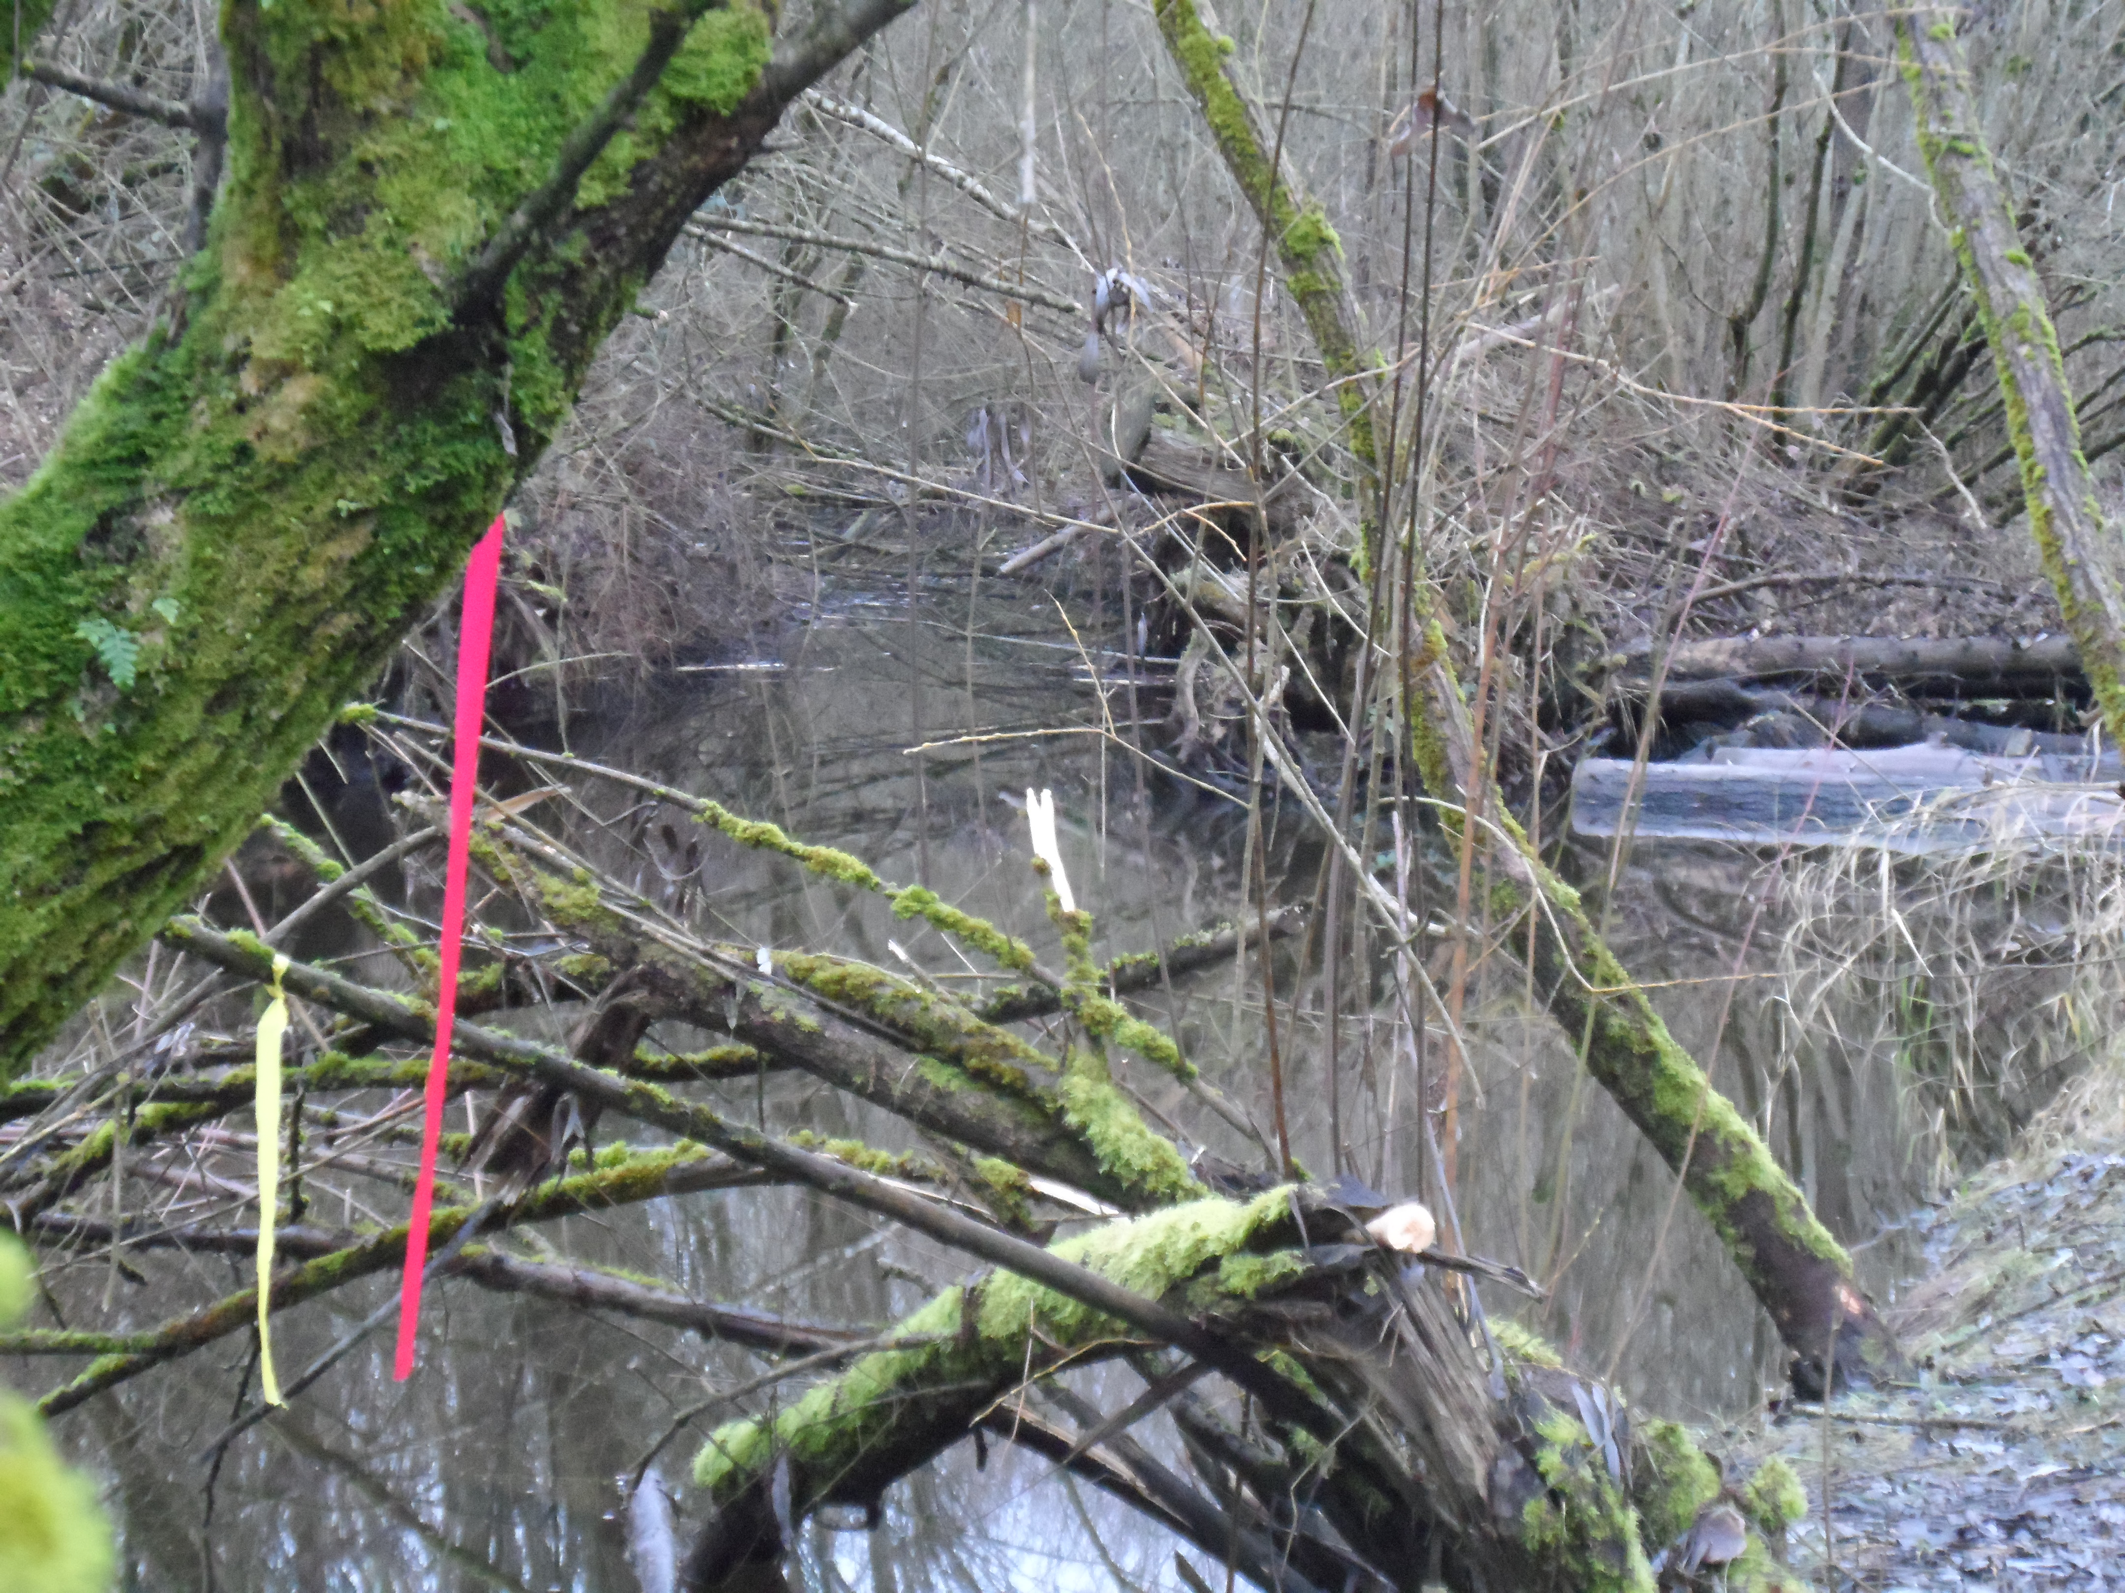
Photo by Kent Parkinson

Figure 3.
Water quality sample Site (3) is on the North Creek and a continued site from Summer quarter. During summer quarter 2013 it was listed as Site 2. We kept this site for the relevance to original reports presented before this study began. It is located approximately 30 meters southeast of the University of Washington Bothell wetlands boardwalk. This site is about 20 meters south of the secondary out flow. Its GPS coordinates are N47.76070/W122.18732
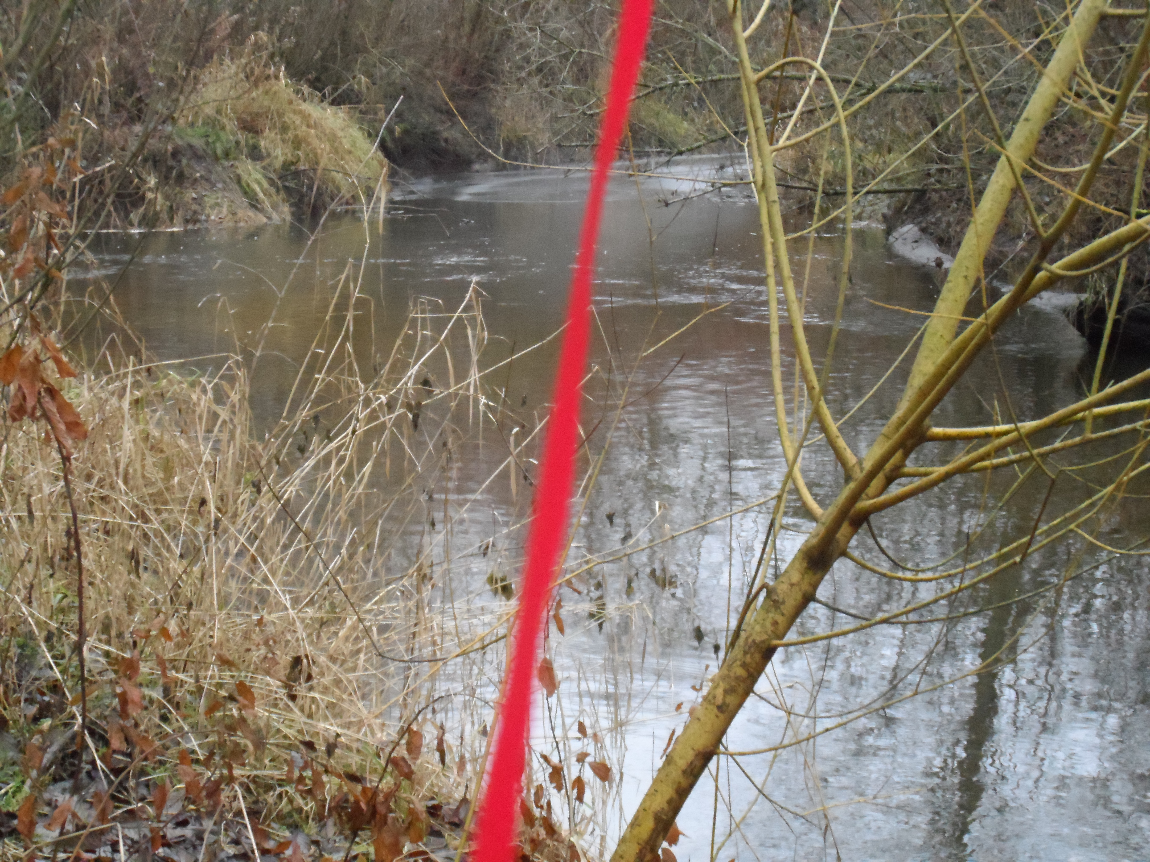
Photo by Kent Parkinson

Figure 4.
Water quality sample Site (4) is on the North Creek and a continued site from all three quarters under the same listing for Spring 2013 and Summer 2013 as Site 1, and Site 4 for Fall 2013. It is located the furthest south on the University of Washington Bothell wetlands. This site is on the north side of the 522 Highway overpass spanning the main trail and North Creek. This site is relevant for all waters leaving the University of Washington Bothell campus wetlands. Its GPS coordinates are N47.75748/W122.18893
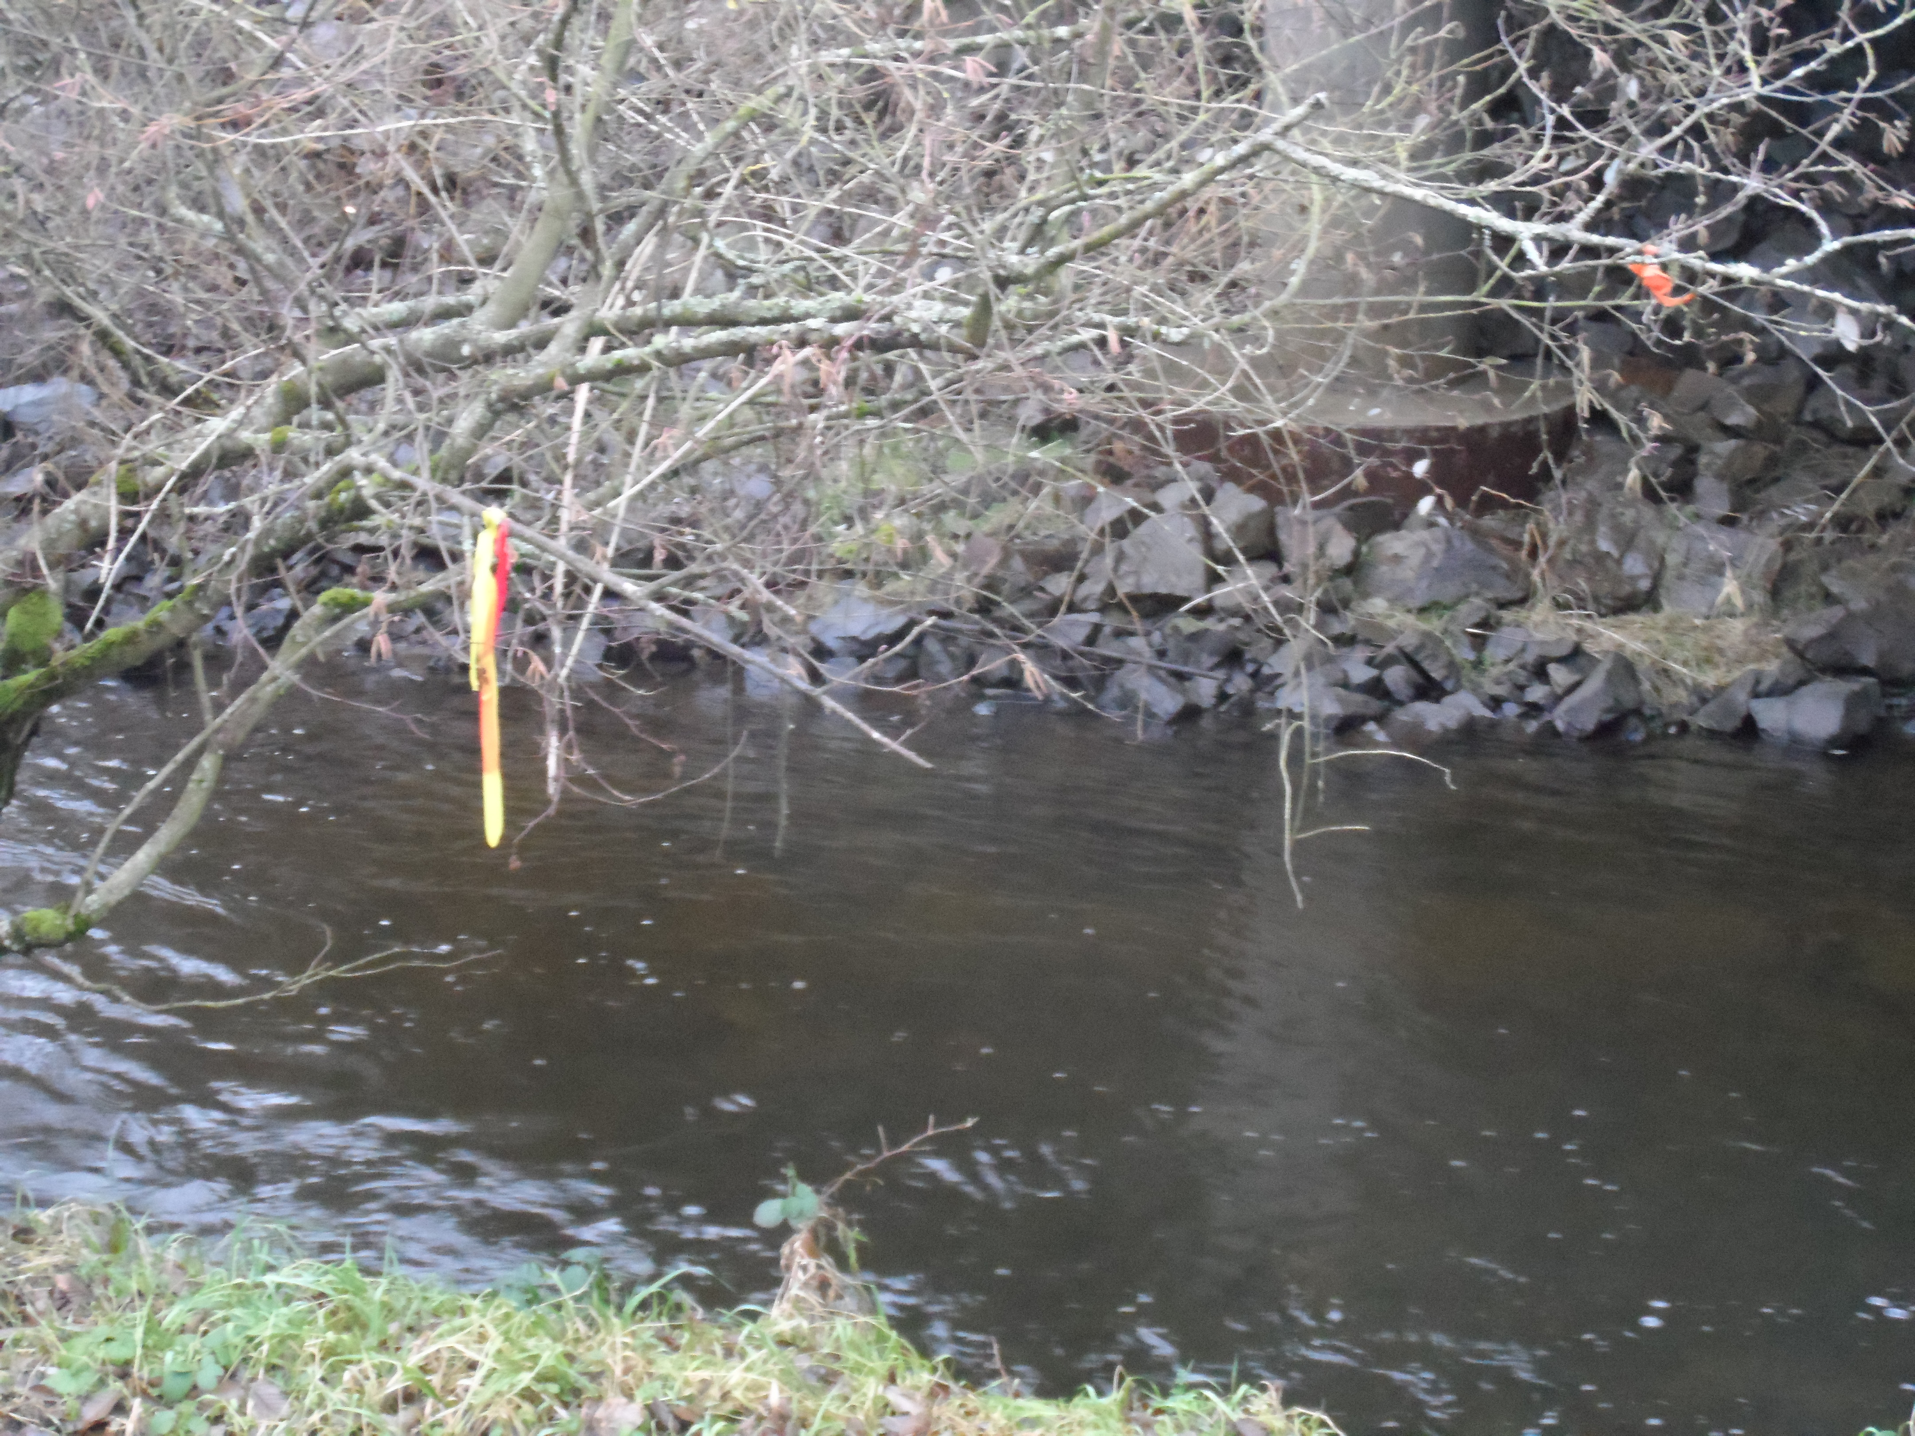
Photo by Kent Parkinson

Appendix 1.
Raw data for North Creek Site 1 located on the east side of Interstate 405 North of the University of Washington’s Bothell campus wetlands. NDA signifies that there was no data available.
Date | Temp (°C) | pH | Conductivity (uS) | Mean Turbidity (NTU) | Dissolved Oxygen (mg/l) | Dissolved Oxygen (% Sat) | Mean Other Coliform Colonies per 100 mL | Mean E Coli Colonies Per 100 mL | Mean Total Coliform Colonies per 100 mL
10/01/13 | 12.6 | 7.2 | 106.1 | 4.07 | 9.84 | 89.3 | 3800 | 34 | 3834
10/08/13 | 11.8 | 7.3 | 141.6 | 2.44 | 9.08 | 84 | 10100 | 234 | 10334
10/15/13 | 9.6 | 7.4 | 131 | 2.79 | 10.61 | 93.4 | 1900 | 134 | 2034
10/22/13 | 10.5 | 7.7 | 139.5 | 3.6 | 9.96 | 89.3 | 1634 | 400 | 2034
10/29/13 | 7.5 | 7.4 | 128 | 3.12 | 10.71 | 89.5 | 2667 | 200 | 2867
11/05/13 | 7.9 | NDA | 32.8 | NDA | 8.06 | 68.5 | 1300 | 534 | 1833
11/12/13 | NDA | NDA | NDA | NDA | NDA | NDA | NDA | NDA | NDA
11/19/13 | 9.1 | 6.8 | 128.1 | 5.91 | 10.64 | 92.1 | 3034 | 267 | 3300
11/26/13 | 4.8 | 7.7 | 176.3 | 4.15 | 11.79 | 91.7 | 2000 | 134 | 2134
12/3/2013 | 5.1 | NDA | 150.1 | 8.52 | 12.15 | 95.7 | 2200 | 234 | 2434

Appendix 2.
Raw data for North Creek Site 2 located ~ 30 meters north of the secondary channel on the University of Washington’s Bothell campus wetlands. NDC signifies that there was no data available.
Date | Temp (°C) | pH | Conductivity (uS) | Mean Turbidity (NTU) | Dissolved Oxygen (mg/l) | Dissolved Oxygen (% Sat) | Mean Other Coliform Colonies per 100 mL | Mean E Coli Colonies Per 100 mL | Mean Total Coliform Colonies per 100 mL
10/01/13 | 12.4 | 7.2 | 108.1 | 3.47 | 9.52 | 88.6 | 3734 | 134 | 3868
10/08/13 | 11.9 | 7 | 141.9 | 2.97 | 9.55 | 88.6 | 7234 | 267 | 7501
10/15/13 | 9.6 | 7.7 | 95.6 | 2.58 | 12.22 | 107.9 | 667 | 67 | 734
10/22/13 | 10.5 | 7.2 | 139.1 | 3.29 | 7.69 | 86.3 | 2000 | 200 | 2200
10/29/13 | NDA | NDA | NDA | NDA | NDA | NDA | NDA | NDA | NDA
11/05/13 | 8.2 | 7.1 | 111.2 | 2.67 | 9.98 | 84.3 | 1600 | 200 | 1800
11/12/13 | NDA | NDA | NDA | NDA | NDA | NDA | NDA | NDA | NDA
11/19/13 | 9.1 | 7.2 | 124.7 | 7.95 | 10.13 | 88.1 | 6300 | 867 | 7167
11/26/13 | NDA | NDA | NDA | NDA | NDA | NDA | NDA | NDA | NDA
12/3/2013 | 5.1 | 7.6 | 152 | 3.86 | 12.5 | 94.4 | 2200 | 1034 | 3234

Appendix 3.
Raw data for North Creek Site 3 located ~30 meters southeast of the University of Washington Bothell wetlands boardwalk. This site is ~10 meters south of the secondary out flow. NDC signifies that there was no data available.
Date | Temp (°C) | pH | Conductivity (uS) | Mean Turbidity (NTU) | Dissolved Oxygen (mg/l) | Dissolved Oxygen (% Sat) | Mean Other Coliform Colonies per 100 mL | Mean E Coli Colonies Per 100 mL | Mean Total Coliform Colonies per 100 mL
10/01/13 | 12.2 | 7.1 | 51.6 | 3.94 | 8.83 | 82.9 | 2233 | 34 | 2267
10/08/13 | 11.9 | 7 | 140.9 | 4.15 | 9.26 | 85.7 | 4767 | 700 | 5467
10/15/13 | 9.6 | 7.7 | 89.1 | 2.52 | 11.45 | 101.2 | 2867 | 1034 | 3901
10/22/13 | 10.4 | 7.2 | 139.4 | 2.85 | 10.46 | 93.3 | 3634 | 934 | 4568
10/29/13 | NDA | NDA | NDA | NDA | NDA | NDA | NDA | NDA | NDA
11/05/13 | 8.1 | 7.1 | 111.4 | 3 | 10 | 85.8 | 1700 | 234 | 1933
11/12/13 | NDA | NDA | NDA | NDA | NDA | NDA | NDA | NDA | NDA
11/19/13 | 9.1 | 7.2 | 129.6 | 7.64 | 10.1 | 87.2 | 7800 | 1300 | 7634
11/26/13 | 4.4 | 7.7 | 84.1 | 4.87 | 8.66 | 66.7 | 2467 | 767 | 3067
12/3/2013 | 5 | 7.7 | 151.8 | 3.86 | 11.82 | 93.4 | 2667 | 667 | 3934

Appendix 4.
Raw data for North Creek Site 4 located the furthest south on the University of Washington Bothell wetlands. This site is on the north side of the 522 Highway overpass spanning the main trail and North Creek. NDC signifies that there was no data available.
Date | Temp (°C) | pH | Conductivity (uS) | Mean Turbidity (NTU) | Dissolved Oxygen (mg/l) | Dissolved Oxygen (% Sat) | Mean Other Coliform Colonies per 100 mL | Mean E Coli Colonies Per 100 mL | Mean Total Coliform Colonies per 100 mL
10/01/13 | 12.1 | 7.1 | 107.4 | 4.4 | 9.82 | 91.1 | 1733 | 670 | 2403
10/08/13 | 11.8 | 7 | 140.9 | 3.79 | 10.31 | 93.7 | 5600 | 634 | 12768
10/15/13 | 9.3 | 7.6 | 174.4 | 2.51 | 12.87 | 111.9 | 1800 | 300 | 2100
10/22/13 | 10.3 | 7.2 | 137.7 | 2.54 | 10.24 | 92 | 2434 | 867 | 3301
10/29/13 | 7.2 | 6.9 | 190.5 | 2.91 | 11.6 | 96 | 4867 | 1034 | 5900
11/05/13 | 8.1 | 7.1 | 110.7 | 2.68 | 10.1 | 85.4 | 3034 | 567 | 3600
11/12/13 | NDA | NDA | NDA | NDA | NDA | NDA | NDA | NDA | NDA
11/19/13 | 9.1 | 7.1 | 128.3 | 7.87 | 10.69 | 92.7 | 7800 | 1834 | 9634
11/26/13 | 4.2 | 7.7 | 175.6 | 3.6 | 12.17 | 93.4 | 2467 | 467 | 2934
12/3/2013 | 5 | 7.5 | 153 | 3.89 | 12.78 | 100.2 | 3467 | 500 | 3967

