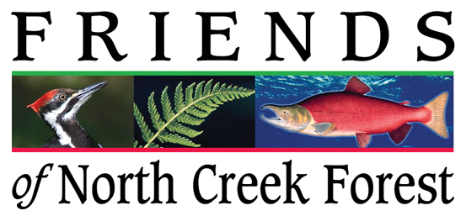

Proposition 1

Dear Voters and Supporters,

Proposition 1 - Parks and Public Spaces levy, includes funding to complete conservation of North Creek Forest. While this is only a fraction of the full levy, it is a critical part of this quality of life choice.

There is a Purchase Option on North Creek Forest land, which expires on July 31st 2015. After that time logging and development are a real threat. Even if we continue to get grants, the money will not arrive in time for negotiations between the City and landowners to be completed. We simply need to pass the levy or risk having a gaping hole in the middle of North Creek Forest.

We have come a long way in the last 4 years. When Friends was founded nothing had been saved. Zero. Within 11 months we raised the money and the City took ownership of 35 acres. That has now grown to almost 42 acres.

Along the way we have won awards from three Land and Water grants. These are among the most difficult grants to apply for and give the land the highest protection from future development found in the United States. On our last application we scored First Place in the whole state. But that grant will only be for $500,000. That leaves the city short about $1M.

Prop 1 is the solution.

Proposition 1 - Parks and Public Spaces levy will cost under $10 per month, or under $120 per year per $300,000 of home value. That is under $3000 over 25 years. The changes to Bothell from this levy would probably increase home values many times that amount.

We urge you to vote YES on Proposition 1 - Parks and Public Spaces.

Thank You,
Friends of North Creek Forest

For additional information go to: Bothell Wins!

