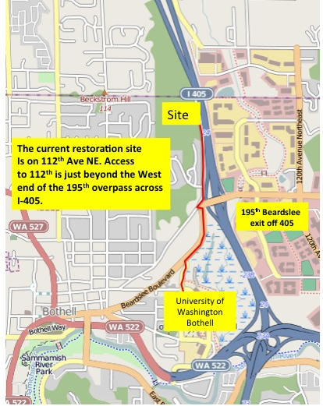

The 2012-2013 UW-Restoration Ecology Network site is located on the east edge of North Creek Forest along a dead end road (112th Ave NE). From the campus turn right onto Beardslee Blvd. Turn left just before reaching the 195th overpass. Then make an immediate right. Proceed North. The site is about 100 meters before the end of the road.

From I-405 take the 195th exit. Just beyond the bridge take a right and another right. Proceed North. The site is about 100 meters before you reach the end of 112th.

