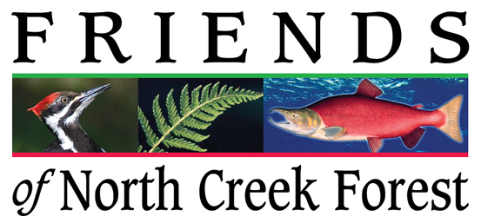

Nonprofit Environmental Organization - Paid Internship

Our Mission: We maintain and improve the ecological function of North Creek Forest through stewardship, education and conservation in perpetuity.

Goal of this internship: Assist a highly successful grassroots environmental organization to grow from an all-volunteer organization to a staffed and sustainable asset to our community and to the City of Bothell. The intern will “shadow” our Executive Director and work in all areas of our organization.

- Flexible hours

- Organize/promote a variety of stewardship, educational, and fundraising events

- Integrate latest and best administrative and management practices into this vigorous but currently all-volunteer organization.

- Work with city government, elected officials, tribes, schools and other environmental organizations to offer an innovative blend of education, stewardship and conservation solutions.

Basic Qualifications:  - Absolute belief in our mission  - Strong will to learn and to teach  - Excellent communicator in all forms  - Manage date in many forms  - High level of computer competency  - Fit for forest work in all weather | Preferred Qualifications:  - Course work or degree in environmental studies + business or non-profit management.  - Proficient in use of social media

This is a six-month paid internship averaging 20 hr/wk @ $18/hr

Applicant instructions:

- Please become familiar with our organization before applying. http://www.friendsnorthcreekforest.org

- Email your cover letter, resume and portfolio to:
Jim Freese - Executive Director
Jfreese@friendsnorthcreekforest.org
(Please keep portfolio under 5MB)

Finalists will be interviewed in May.
The internship runs from mid June through mid December.

