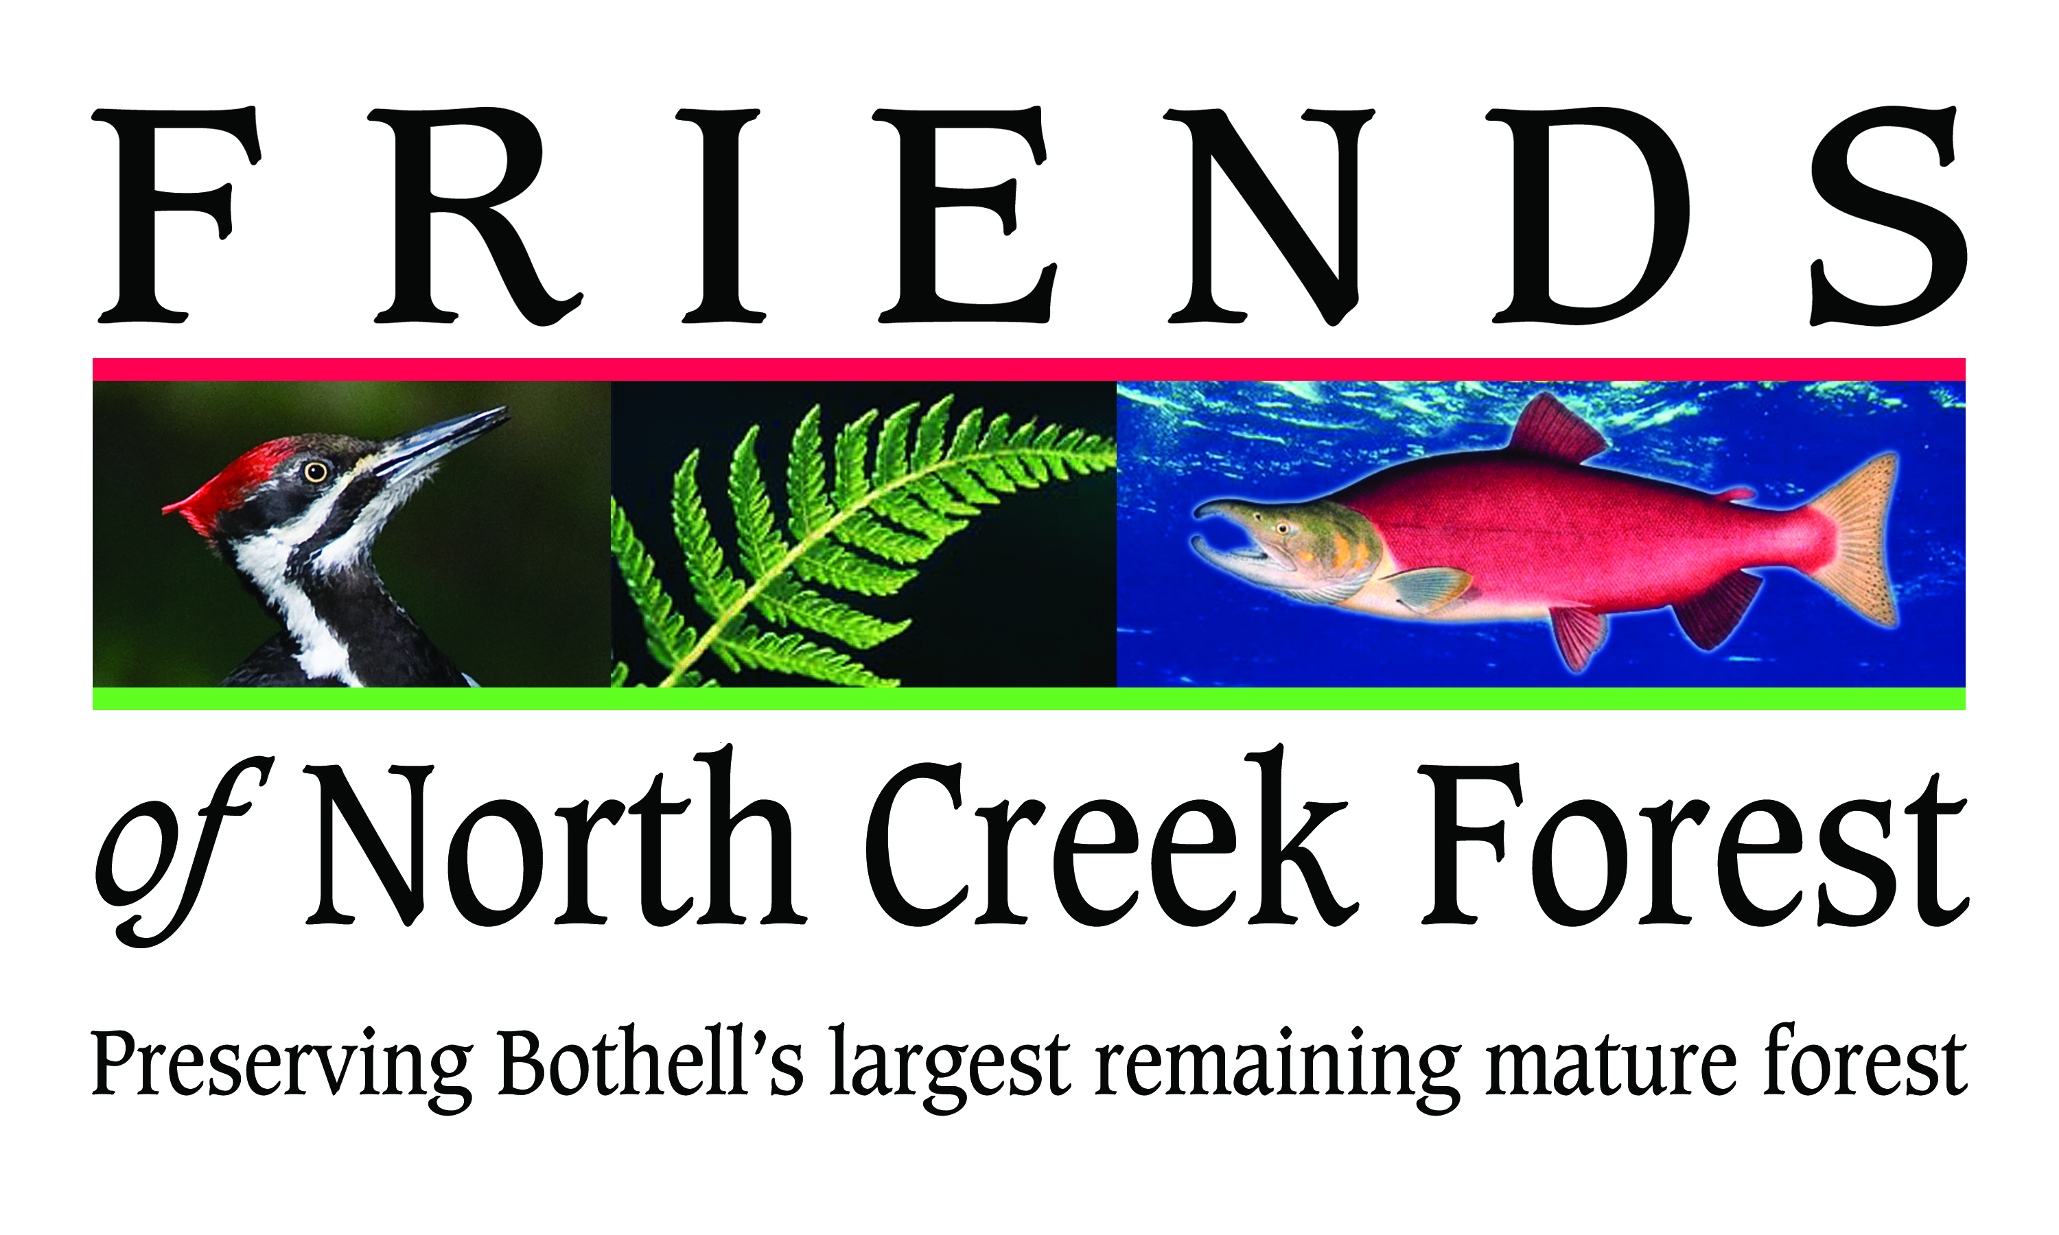
Internship Opportunities
With
Friends of North Creek Forest

Friends of North Creek Forest, a Bothell-based non-profit organization, is pleased to offer an unpaid internship program for college students. Friends of North Creek Forest is working to acquire, steward, and conduct educational programs in the forest between the University of Washington Bothell/Cascadia Community College campus and Canyon Park Junior High School. We have over 40 acres of the forest available for interns to use, with efforts to acquire the remaining acreage continuing. Our organization is growing and administrative interns are also welcome. Internships will be offered each quarter for the foreseeable future.

The internship program will be supervised by the FNCF Director, and/or Dr. David Bain, who spent over 10 years as an affiliate faculty member at the University of Washington. Academic credit for internships may be available by mutual agreement among the intern’s school, Friends of North Creek Forest, and the intern.

Internships will provide students with valuable opportunities to advance their careers through learning about and gaining practical experience in one or more of the following areas of their choice:

Biology

Interns will participate in studies that document plants, fungi, and animals throughout the forest. This may include identifying and mapping plants, specific biological communities such as wetlands, recording and mapping animal signs, assessing microhabitats, photography, and data entry, analysis and presentation.

Earth Sciences

Interns will participate in efforts to identify and map physical environmental features such as soil types, general topography and steep slopes, evidence of erosion and slope instability, and surface geological features.

Information Science & Technology

Interns will help to design and maintain a database to archive data and present information collected on the biology and geology of the forest. They may also participate in the development of remote electronic data recording and communications systems. For such efforts, interns may also help to design, build and evaluate power sources for signage, cameras and other remote sensors within the forest.

Media and Communication

Interns will participate in the development of video, photographic, graphic and text material for communication with the public and policy-makers about the forest. This could include website design.

Land Use Policy and Planning

Interns will engage with local political leaders regarding issues that affect the forest. These include funding for acquisition and stewardship, transfer of development rights policy, watershed protection policy, transportation, and accessibility for people with disabilities.

Education

Interns will work with teachers in local schools to conduct pilot scale educational field trips to North Creek Forest.

Non-Profit Fundraising & Grant Writing

Interns will explore funding opportunities for forest acquisition and stewardship, including education programs within the forest. They will work with a grant writer to learn budgeting and grant writing skills.

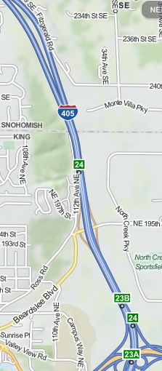

North Creek Forest

To Apply

More information about Friends of North Creek Forest can be found at www.friendsnorthcreekforest.org. Interested students should contact Krystle Minerich at kminerich@friendsnorthcreekforest.org with a letter summarizing area of interest and relevant education and experience. Students accepted into the program will develop a statement of understanding for the work to be done during the quarter, a schedule for meeting with supervisors, and evaluation criteria, before starting work.
UWB
CCC

