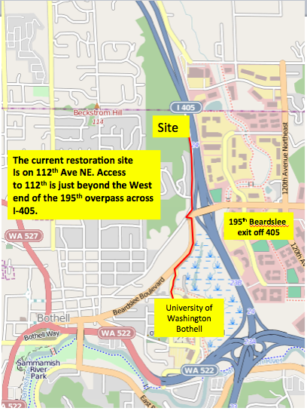

At the intersection of 195th at I-405 take the turn off on Beardslee Boulevard and go north (to the right). Proceed about 1/3 mile until you see the piles of mulch. See you soon!

